Community Travel Blog

Emily Quevedo

CST-451 Capstone Project Requirements Document

Grand Canyon University

Instructor: Professor Mark Reha

Revision: 3.0

Date: April 4, 2021

**ABSTRACT**

Social networking sites allow thousands of users to share and connect with others. Experienced travelers will be able to introduce new places and ideas for those who did not know existed. People would also be able to receive helpful tips and guidance from those who have personally visited a certain destination. There are inexperienced travelers who could be lost and unprepared to make their first trip, but they could discover a new, interesting place along with some advice.

This document will discuss the project requirements by providing various diagrams, interface layouts, and a description of what tools and technologies will be used. One of the diagrams shown include use cases, which represents the interaction between the user and the application. Another diagram includes a sitemap, which helps organize the connections between the website’s pages and content. The last diagram is the logical system diagram. This diagram will illustrate the structure of the website and how the information will flow.

|  |
| --- |
| History and Signoff Sheet |

**Change Record**

|  |  |  |
| --- | --- | --- |
| **Date** | **Author** | **Revision Notes** |
| 9/27/20 | Emily Quevedo | Initial draft for review/discussion |
| 10/9/20 | Emily Quevedo | Implemented feedback from evaluator |
| 3/26/21 | Emily Quevedo | Reviewed and updated diagrams |

|  |
| --- |
| **Overall Instructor Feedback/Comments** |

|  |
| --- |
| **Overall Instructor Feedback/Comments** |

**Integrated Instructor Feedback into Project Documentation**

Yes  No

**TABLE OF CONTENTS**

Functional Requirements 4

Non-Functional Requirements 5

Technical Requirements 6

Logical System Design 7

User Interface Design 8

Reports Design 9

Functional Requirements

**Use Cases**

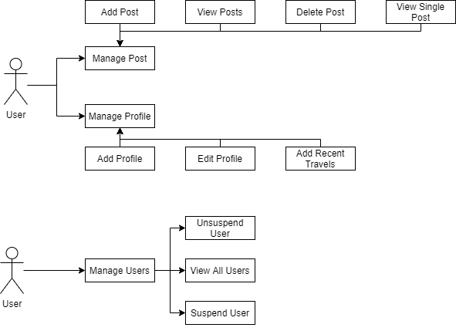

|  |  |  |
| --- | --- | --- |
| **Use Case or User Story** | **Approval Date** | **Justification** |
| N/A | N/A | N/A |

Non-Functional Requirements

**Use Cases**

Link to user stories: <https://github.com/EmilyQue/SeniorCapstone/blob/main/documents/User%20Stories_Revised.xls>

|  |  |  |
| --- | --- | --- |
| **Use Case or User Story** | **Approval Date** | **Justification** |
| N/A | N/A | N/A |

Technical Requirements

**Use Cases**

The technologies that will be used in this project are Laravel framework, MySQL, HTML/CSS. The tools that I will be utilizing are Visual Studio Code and Xampp. The reason why I decided on Laravel is because it already follows the MVC architecture, which makes it helpful when managing code. I also decided on using Visual Studio Code and Xampp because it is one of the tools that I feel comfortable and experienced with using. For hosting, I will be using Heroku because it is a tool that I have the most experience with. Monitoring will be done through Uptime Robot.

|  |  |  |
| --- | --- | --- |
| **Technology or Tool** | **Approval Date** | **Justification** |
| N/A | N/A | N/A |

Logical System Design

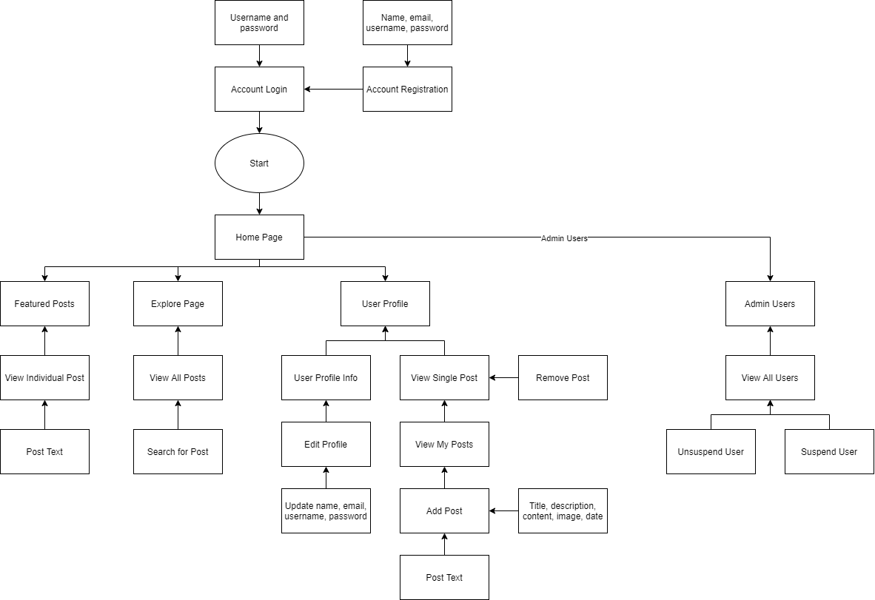

User Interface Design

Site Map

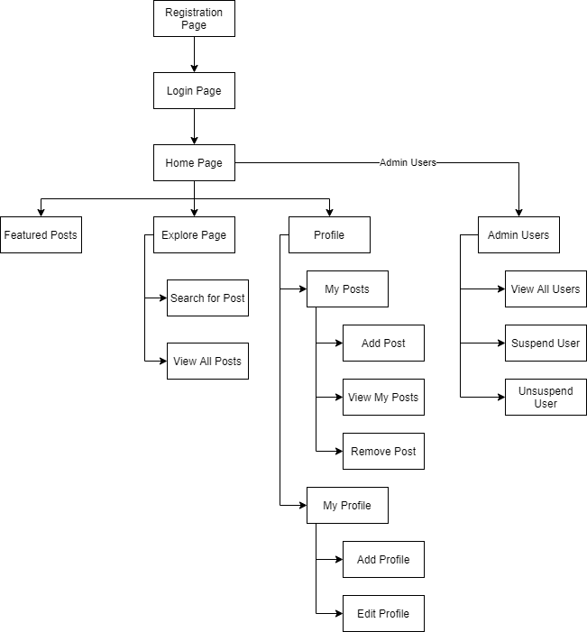

UI Interface Sketches

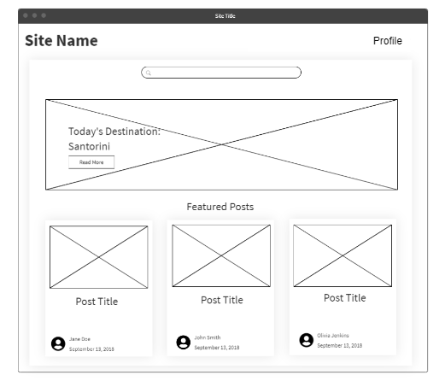

Home page will display an image banner and featured posts below

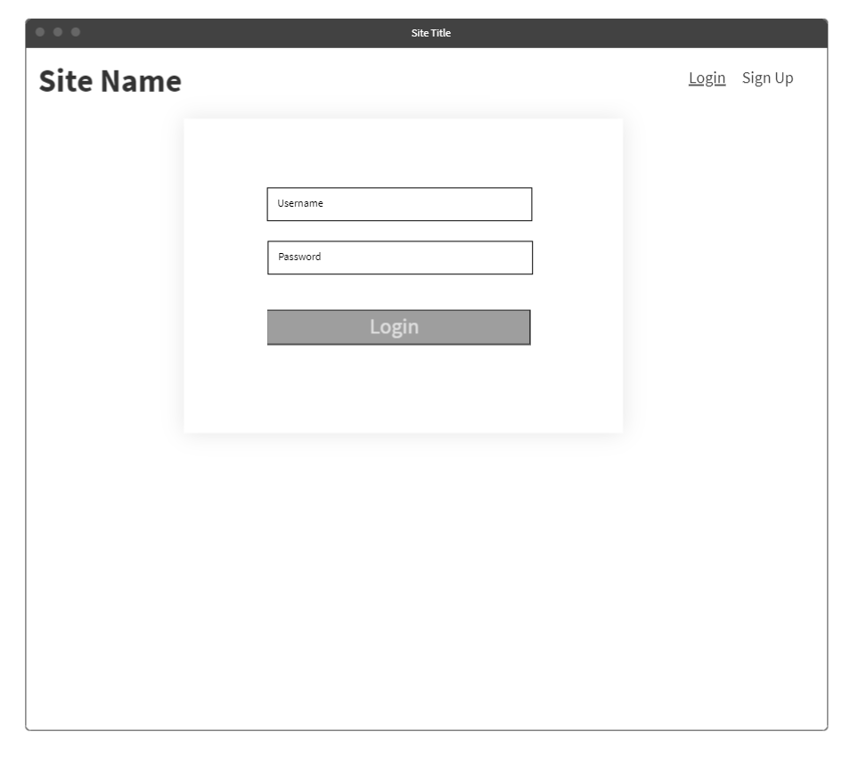

Login page where the user has to authenticate their account credentials.

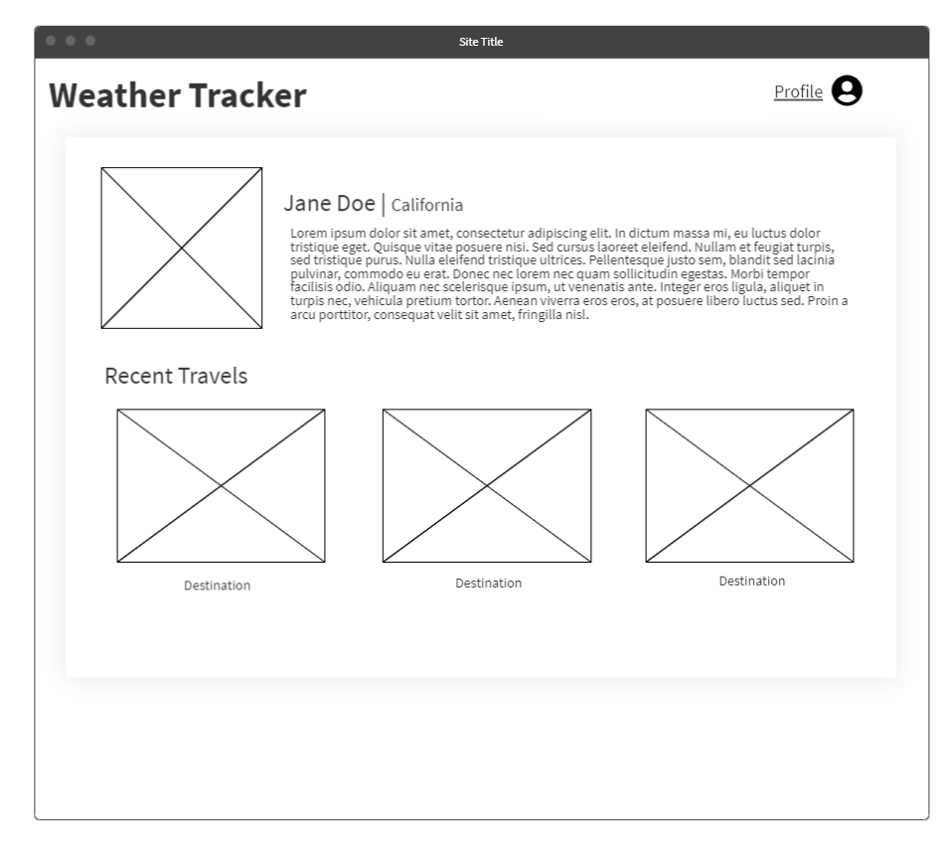

Profile page that displays the logged in user’s name, location, profile picture (not required), and a small biography. This page also includes a recent travels section on the profile page where the user can list their recent trips.

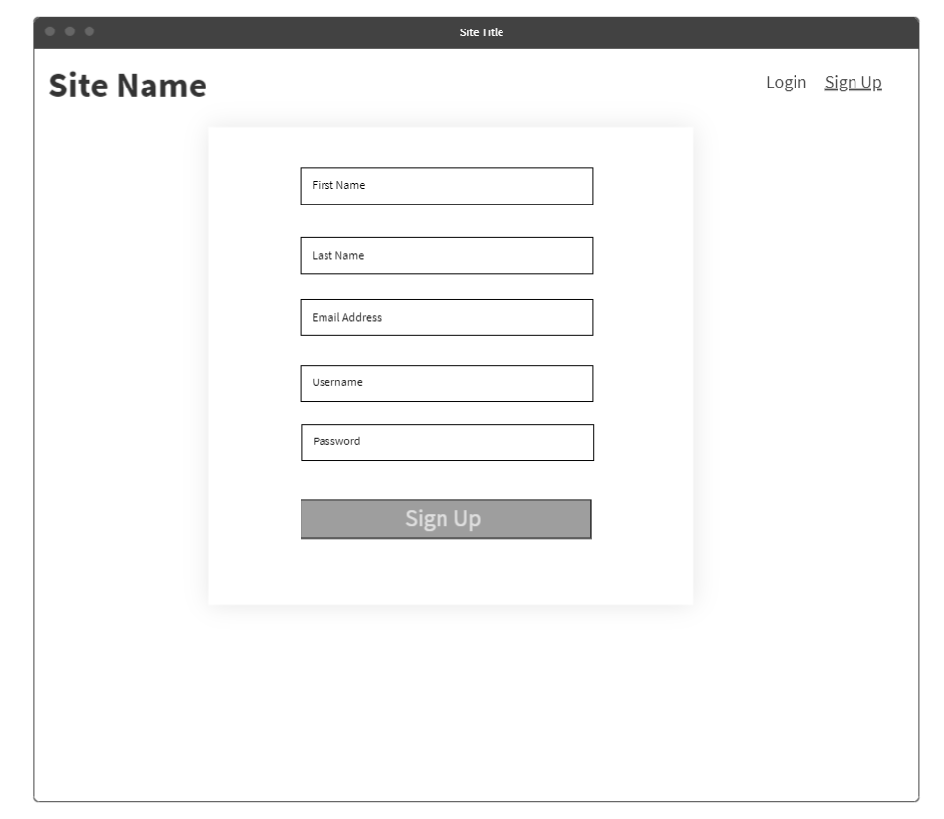

Registration page where the user creates an account in order to interact with others.

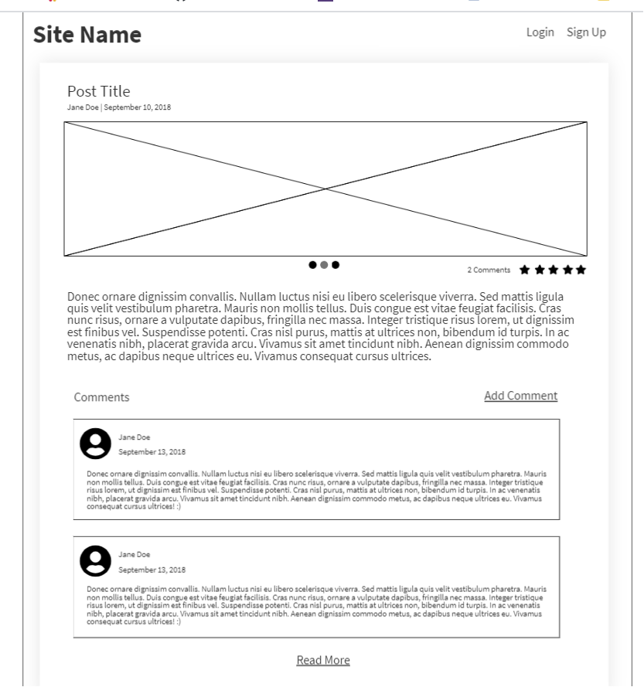



Single post view, which shows the page once the user has clicked on the post. It will display the title of the post, the date it was created, a picture, and the description.

**Reports Design**

Users

* Number of registered users

Posts

* Number of posts
* Number of comments